## Requirement Set up for PLC

* Create Database Connection Setting

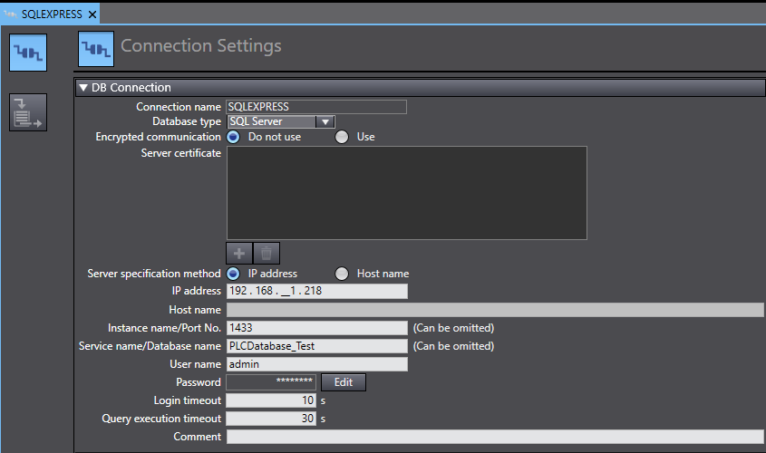

* Create a Global Publish Variable to allowed the C# Program to read
  + 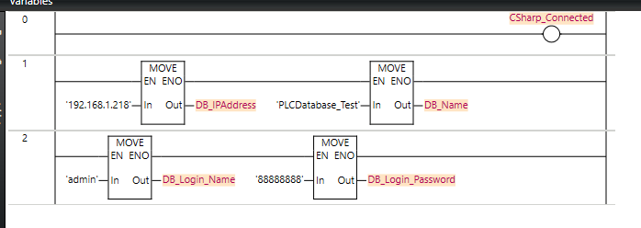**CSharp_Connected** to test if the programme can read the variable from the PLC
  + **DB_IPAddress**, **DB_Name**, **DB_Login_Name**, **DB_Login_Password** is for creating the connection string to used by the programme to query.
  + The variable name must be **exactly the same** due to the programme has specifically set to read those variable name.
* PLC DB Connection Test
  + 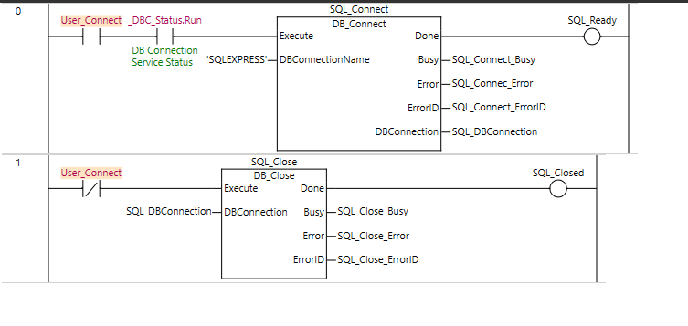Used to test if the PLC can be connected to the SQL Server
* PLC DB Simulate
  + 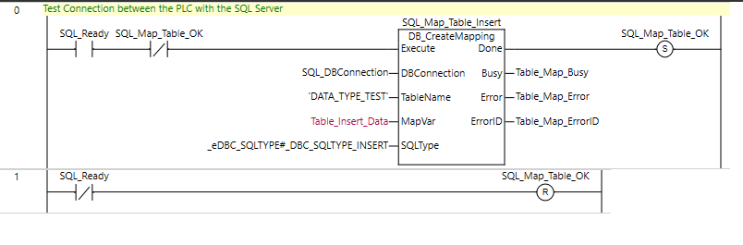Used to map the Data Structure to the table created and the simulate if the data can be insert into the table.
* PLC DB Insert Data
  + 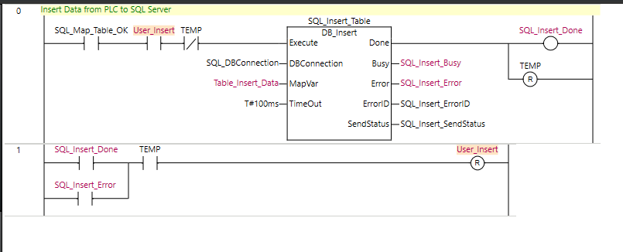Insert the Data into the table in the database
* Remeber to publish global variable so that the programme can read them

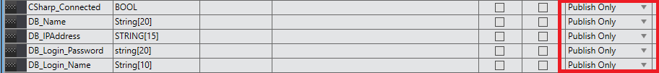

## SQL Server Setup

* Enable TCP/IP for the SQL Server (it is disabled on default)

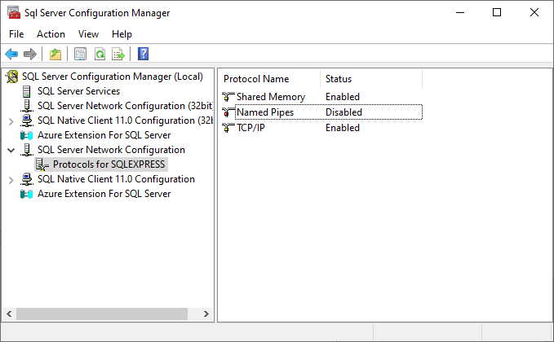

* Got to the Properties, go to IPAll, Delete Dynamic Ports and put 1433 for TCP Port

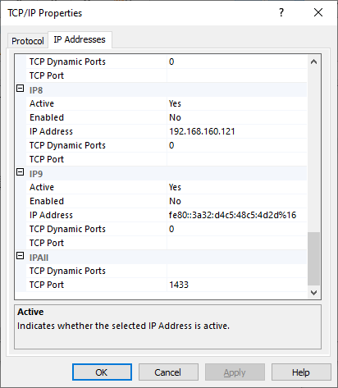

* After that, restart the SQL Server and it will be able to connect by using the IP Address
* Create Login

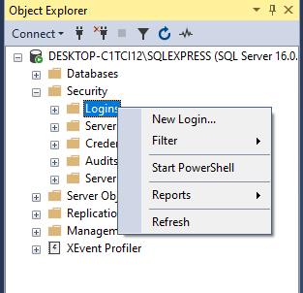

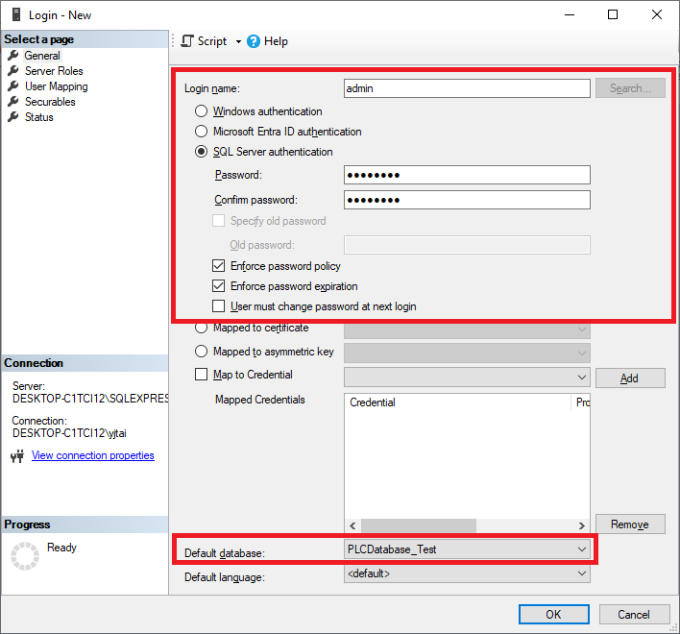

Create New User, checked SQL Server authentication, type in the login name, password, and select the default database if you want (optional, will not affected in the PLC)

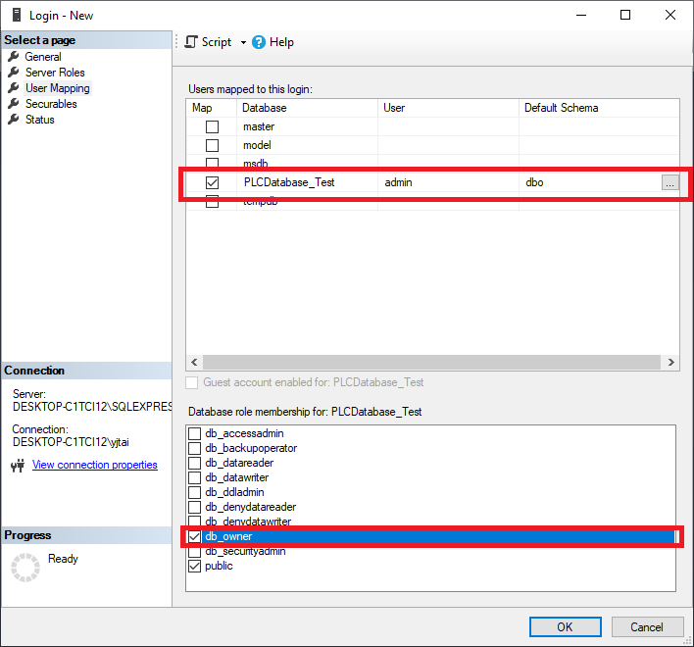

Go to User Mapping, Select the database this user can access, checked the database and the db_owner at the bottom section to ensure this user able to insert data.

Firewall Inbound for SQL Server Port

go to Windows Defender Firewall with Advanced Security > Inbound Rules > New Rules

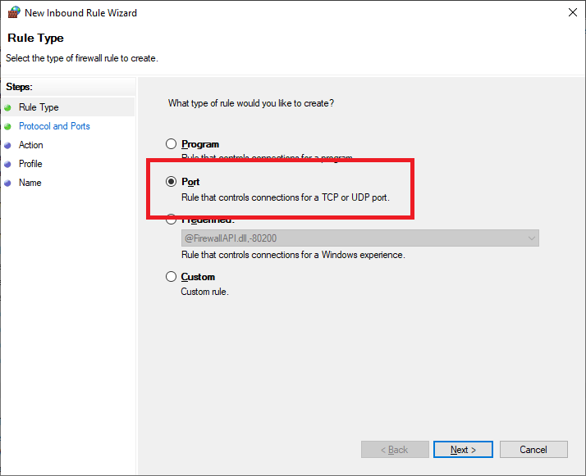

Select Port> Specific Local Port : 1433 > Allow the connection > Apply to all Domain, Private, Public> and name the rule

## Table Creation

* For table creation, name of the table can be vary but change in the DB Mapping to the same as the table name. The column name must be same as the data member in the data structure

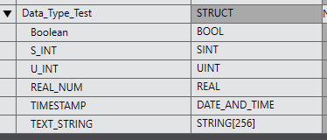

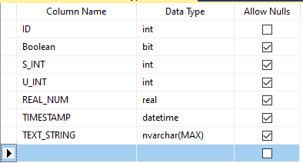

ID is not connected to PLC but it is a must to ensure the data is inserted in order

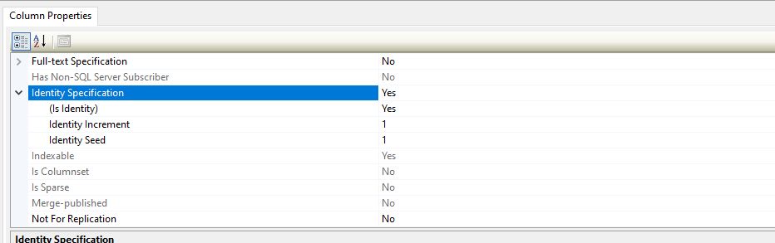Turn on the Identity Specification for the ID to be increment by 1 for every data added.

IMPORTANT: only use **ID** as the column name because the program will be referencing this column.

Alternative way using SQL Query:

1 **CREATE** **TABLE** [dbo].[Data_Type_Test] (

2 [ID] INT **IDENTITY** (1, 1) **NOT** **NULL**,

3 [Boolean] BIT **NULL**,

4 [S_INT] INT **NULL**,

5 [U_INT] INT **NULL**,

6 [REAL_NUM] REAL **NULL**,

7 [**TIMESTAMP**] DATETIME **NULL**,

8 [TEXT_STRING] NVARCHAR (**MAX**) **NULL**

9 );

Run this query to create the table, (rmb to replace the table name and column name)

Database name = Module Name

Table name = Station Name, Data Structure Name

Column name = Data Member

Fixed Column Name

ID, DATETIME, LOTNUMBER

Fixed Table Name: Calibration

*not case sensitive for SQL